Merge Duplicate Dependent Accounts from Alias to Authoritative Domain Object
  - cyberark-discovery-dependency-deduper.ps1

Script functionality
cyberark-discovery-dependency-deduper.ps1:
- Finds discovery dependencies/usages that use an alias domain (for example domain.edu).
- Matches them to authoritative domain dependencies (for example subdomain.domain.edu) using your alias map.
- Produces a dry-run plan in CSV.
- When script is run with -Apply, it:
  - Merges “useful” config from the alias dependency into the authoritative one.
  - Archives the alias JSON to disk.
  - Deletes the alias dependency from Privilege Cloud.
  - Writes a post-state CSV so you can verify the result.
Everything is done via the Privilege Cloud REST APIs.

Parameters that matter in Privilege Cloud on ISPSS
For ISPSS you should ignore the classic PVWA logon and always use a token:
- -PVWAUrl
Base tenant URL. For ISPSS:
https://subdomain.privilegecloud.cyberark.cloud
- -BearerToken
A pre-acquired token for Privilege Cloud.
The script will send:
Authorization: Bearer <BearerToken>
In practice you will usually get this from IdentityAuth.psm1 or another ISPSS flow.
- -AliasMapPath or -AliasMap
Mapping from alias domain to authoritative domain. Example mapping:
  - 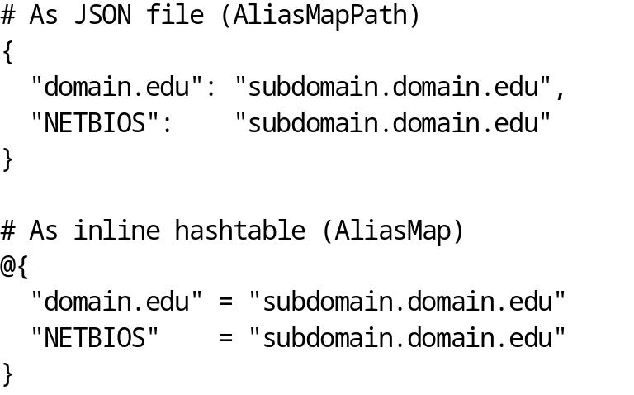
If you provide neither, the script uses a default, which will not work:
- Filters (optional, but highly recommended to start)
  - -SafeFilter "SomeSafe","OtherSafe"
  - -PlatformIdFilter "WinDomain","WinServerLocal","UnixSSH"
  - -AccountNameFilter "*prod*","*svc-*"
- Execution / safety switches
  - -OutDir ".\out" (default). Folder for logs and files.
  - -Apply
Without -Apply you get a read-only dry run.
  - -Force
When used with -Apply, skips the “type YES” confirmation. For automation only.
  - -VerboseRest
Logs each REST call to actions.log.
  - -SkipCertValidation
Disables TLS validation if you absolutely need it for a lab. Avoid in production.

Getting an ISPSS / Identity token
Use whatever pattern you already have. A common IdentityAuth.psm1 pattern is located below. Download the IdentityAuth module and place it in the same folder as the duplicates deletion script. Then, run PowerShell ISE from the folder where both scripts are stored. Paste the following into the ISE console and run it:
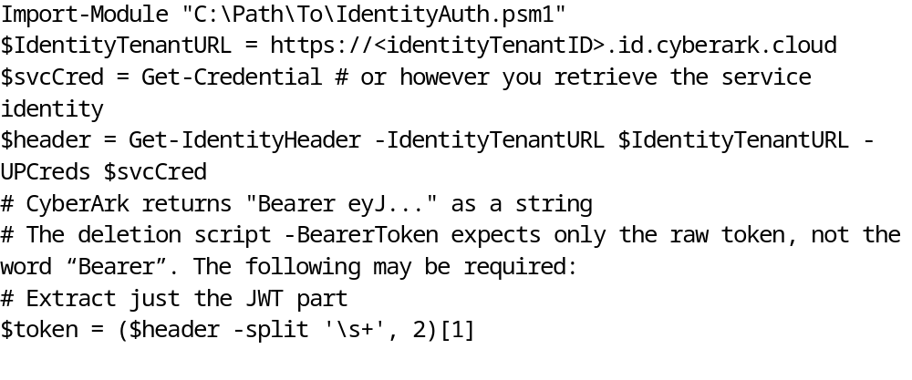
You will use $token in -BearerToken in all examples below.

Dry run (test mode) against Privilege Cloud on ISPSS

Narrow scoped dry run on one Safe
Goal: Build confidence and inspect the planned changes without touching anything. Run the following in PowerShell 7 (PWSH.exe).
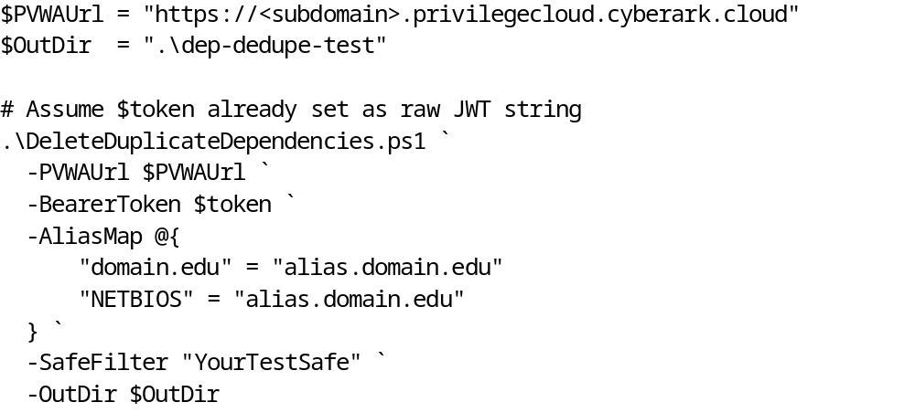
Because you did not supply -Apply, this is a pure analysis run:
In $OutDir you will get:
- actions.log
Text log of what the script did and any warnings.
- raw\acct_<AccountId>.json
Raw dependency/usage JSON per account that was inspected.
- dry-run.csv
Main planning file. For each alias duplicate pair, you will see columns such as:
  - SafeName
  - AccountId, AccountName, PlatformId
  - Type, Machine, ObjectName
  - AliasDomain, Authoritative
  - AliasDepId, KeeperDepId
  - DeltaPropsJson (JSON of the settings that would be merged)
At the end of the run, it writes to the console:
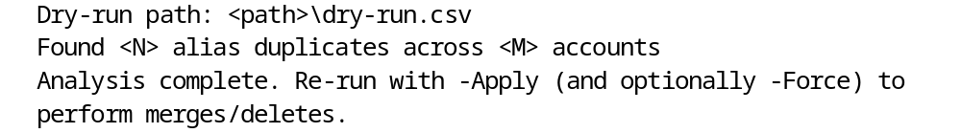
Review dry-run.csv in Excel or Power BI and confirm:
- The alias and authoritative domains are correct.
- The keeper entries are the ones you consider authoritative.
- The deltas look safe to merge.

Wider dry run across a group of Safes
Once the scoped test looks good, you can widen the net:
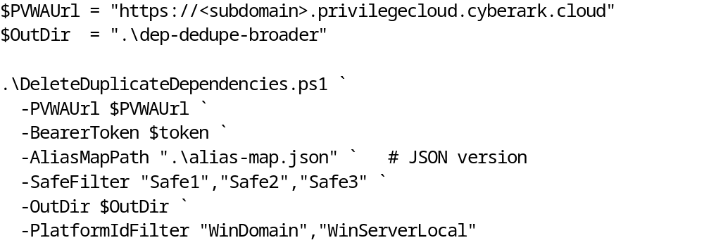
Again, without -Apply this is read-only. Use this as your “final sanity check” before editing anything.

Write run (Merges and deletes)
Once you are satisfied with one or more dry runs:

Interactive write run
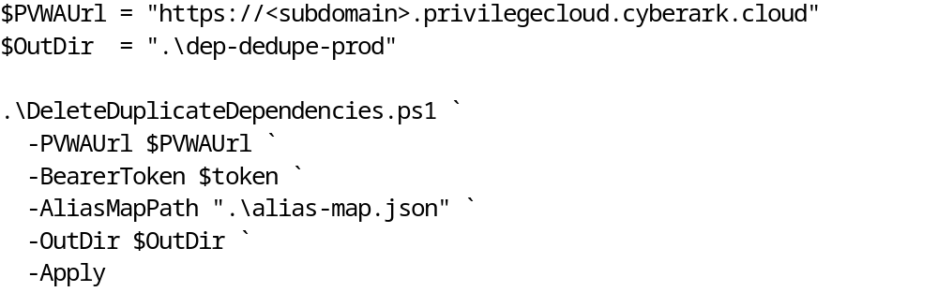
Because -Apply is present, the script will:
- Recompute the same candidate list and rewrite dry-run.csv.
- Show something like:
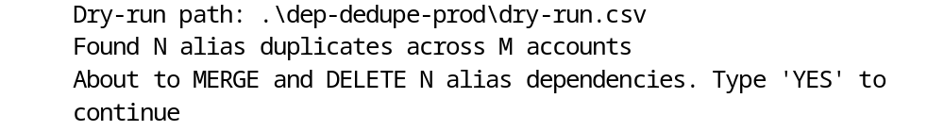
- Wait for you to type YES in all caps and press Enter.
  - Anything else aborts the run.
If you continue, the script will, for each candidate:
- Archive the alias JSON to
archive\alias_acct<AccountId>_dep<DepId>_<timestamp>.json
- Attempt to merge the DeltaProps into the keeper dependency.
- Delete the alias dependency via the API.
- Log each operation to actions.log.
At the end, it calls a post-state verification:
- Re-reads dependencies/usages for all touched accounts.
- Writes post-state.csv to $OutDir.
- Prints a summary:
You can then spot-check post-state.csv and compare it to dry-run.csv and the archive JSONs.

Non-interactive write run (Automation or scheduled task)
If you are scripting this in a scheduled job or CI pipeline and want no prompt:
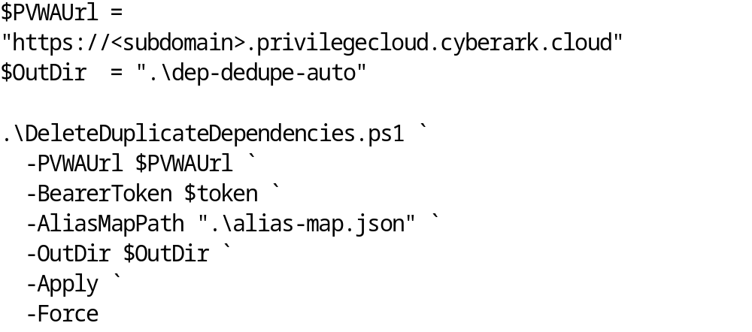
With -Force:
- The script does not prompt for YES.
- It goes straight into merging and deleting.
Use this only after you have validated dry runs and at least one interactive production run.

Recommended pattern for day-to-day ISPSS usage
- Acquire token via IdentityAuth or your preferred ISPSS flow, and strip “Bearer ” if needed into $token.
- Maintain an alias map in a checked-in JSON file like alias-map.json.
- Run a scoped dry run when something changes (new domains, new platforms, change to discovery scope).
- Review dry-run.csv and logs.
- Run a controlled write with -Apply (and -Force only when automated and pre-validated).

